**Virtual Machine**

A virtual machine emulates a physical computer, running its own operating system and apps with virtualized resources. It’s isolated from the host system, allowing users to perform secure tasks like testing apps or using different operating systems while optimizing physical hardware.

It enables the simultaneous operation of multiple OS environments—such as Windows and Linux—on a single physical host via a hypervisor, while maintaining strict isolation between them.

**How it works:** A VM exists as a disk image file loaded into an allocated slice of physical hardware resources (CPU, RAM, storage). The hypervisor mediates and ensures that each VM runs independently without interfering with either the host or other VMs.

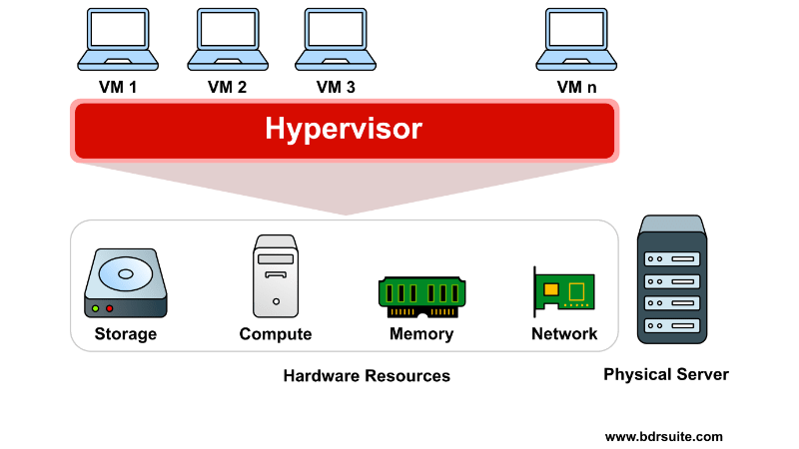

Virtual machines offer flexibility and portability, providing benefits such as:

* **Cost savings—**Using multiple virtual environments on a single infrastructure reduces the physical footprint, lowering server maintenance and electricity costs.
* **Agility and speed—**Creating a new VM is faster and easier than setting up a new environment for developers.
* **Reduced downtime—**VMs can be easily moved between hypervisors, making them ideal for backup if the host fails.
* **Scalability—**VMs simplify app scaling by adding physical or virtual servers, improving app availability and performance.
* **Security—**VMs can run multiple operating systems, allowing you to use a guest OS for insecure apps, thereby protecting your host OS. They enhance security and can isolate viruses, making them useful for safely studying malware.

**Types Of Virtualization**:

**1. Hardware Virtualization**

Also known as server virtualization, this allows multiple virtual machines (VMs) to run on a single physical machine using a hypervisor. Each VM acts as an independent system.  
**Example:** VMware, Microsoft Hyper-V.

**2. Operating System Virtualization**

Multiple user environments (called containers) run on a single OS kernel without the need for separate VMs.  
**Example:** Docker, LXC (Linux Containers).

**3. Application Virtualization**

Applications run on a virtual layer instead of being installed directly on the host OS. This isolates the app from the underlying OS.  
**Example:** Microsoft App-V, Citrix XenApp.

**4. Network Virtualization**

Combines hardware and software network resources into a single software-based administrative entity, enabling more flexible and scalable network management.  
**Example:** VMware NSX, Cisco ACI.

**5. Desktop Virtualization**

A user’s desktop environment is stored on a central server and accessed remotely. Useful for managing multiple users in enterprise environments.  
**Example:** Virtual Desktop Infrastructure (VDI), Citrix Virtual Apps and Desktops.

**6. Storage Virtualization**

Combines multiple physical storage devices into a single virtual storage pool. This simplifies storage management and improves performance.  
**Example:** IBM SAN Volume Controller, VMware vSAN.

**Future trends in Virtual Machines (VMs):**

1. **AI Integration**: AI will make VMs smarter by automating management, optimizing resource use, and enhancing threat detection.
2. **Edge Computing**: VMs will process data closer to devices (like IoT), enabling real-time analytics in smart cities and autonomous systems.
3. **Hybrid Cloud**: VMs will support seamless operations across public, private, and on-premise clouds, improving flexibility and scalability.
4. **Enhanced Security**: Advanced, AI-driven security features will strengthen VM protection against cyber threats.
5. **Container Coexistence**: VMs and containers will work together, enabling legacy systems to run alongside modern apps efficiently.
6. **Quantum Computing**: VMs may eventually integrate with quantum systems, unlocking massive computing potential.

**Common Use Cases:**

* Hosting applications and websites
* Developing and testing software in multiple environments
* Running legacy applications on modern hardware
* Isolating risky workloads for security testing
* Creating training labs for educational purposes

Cloud providers like Azure allow users to choose from various VM sizes and configurations based on performance needs. They support features like **auto-scaling**, **load balancing**, and **integrated monitoring tools**.

In conclusion, virtual machines offer a powerful, flexible, and cost-effective way to manage computing resources, making them a cornerstone in both on-premises data centers and cloud infrastructure.